SPORTS ANALYTICS SOFTWARE TO TRACK ATHLETE PERFORMANCE USING DEEP NEURAL NETWORKS

By

Aditya Ketkar – 2016A7PS0081G Atharv Chandratre – 2017A7PS0009G

April 2019

Table of Contents

Abstract 3

Acknowledgments 4

1. Introduction 5
   1. What is Sports Analytics 5
   2. Why Sports Analytics 6
2. Components 7
   1. The Component Diagram 7
   2. The Raspberry PI 8
   3. The Base Station 8
   4. Deep Neural Network 9
3. Use Cases 10
   1. Use Case Diagram 10
   2. The Actors 10
   3. Utility of the Raspberry PI 11
   4. Utility of Data Storage 11
   5. Utility of Data Processing Unit 12
4. The Process 13
   1. The Swim Lane Diagram 13
   2. Phase 0 14
   3. Phase 1 14
   4. Phase 2 14
   5. Phase 3 15
   6. Phase 4 16
5. Analysis 17
   1. Player Tracking 17
   2. Heat Map 18
6. Conclusion 19

# Abstract

Sports Analytics Software has become the newest trend in the world of professional sports. It is pegged to be a 4.5 Billion dollar industry by 2020 according to some statistics. This tool was first used in the NBA (American National Basketball) to measure the distance traveled by athletes on the court. The utility of such technologies has broadened ever since, with advancements in statistical methods as well as the technologies used in the collection of data. This project explores the usage of Sports Analytics Technology as a simple method to track an athlete using a camera module of a Raspberry PI.

We have planned to implement this through a procedure where we first record a video of the player playing the sport, and then using object detection deep neural network algorithms to analyze his movements. We have chosen Badminton as our sport of choice for this project.

The system should be able to record video at a sufficient Frames per Second rate which will enable the deep neural network model to run efficiently on Google Cloud GPU to perform object detection on the video using ULO object detection framework.

After the data has been processed by the framework, the end users, in this case the athletes and the players should be able to retrieve the data and analyze the feedback. This will be able to point out any points of flaws in their current playing style and make changes to it to gain a competitive advantage over the opponents.

# Acknowledgments

I would like to thank my supervisor, Prof. Rizwan Parveen, for the patient guidance, encouragement and advice she has provided throughout my time as her student. I have been extremely lucky to have a supervisor who cared so much about my work, and who responded to my questions and queries so promptly.

I must express my gratitude to my parents for their continuous support and encouragement.

I would like to also acknowledge my family and friends, thanking them for their thoughts.

# Introduction

## What is Sports Analytics

The practice of sports analytics has been around for decades, but recent advances in data collection and management technology have broadened its scope significantly. The use of data and statistics has become prolific throughout most major sports. In fact, a large portion of professional teams in the world now routinely draw on the services of professional statisticians to support their operations. Tracking a cricket player’s batting average as a basis for measurement of potential or ability is just one of many examples of applying analytics to sports.

Essentially, sports analytics is the practice of applying mathematical and statistical principles to sports and related peripheral activities. While there are many factors and priorities specific to the industry, sports analysts use the same basic methods and approach as any other kind of data analyst. Establishing parameters for measurement, like hit or fumble rate, and consistently collecting data from a broad sample is the basis of the analytics process. This data is then curated and optimized to improve the accuracy and usability of the results.

Sports Analytics includes the use of data related to sports such as players’ statistics, weather conditions, information from expert scouts, etc. and build predictive models around it to make informed decisions. Data management tools, analytical models, information systems are all combined together for the decision-making process. Such information is primarily sought for improving the team performance.

The other section of sports analytics focuses on understanding and maintaining the fan-base of big teams and capturing the eye of investors. There is an increase in the number of informed fans that continuously depend on portals and platforms for following the performance of their favorite teams. The sports agencies depend on such analytical platforms for engaging the investors and increasing the fan-interaction.

With the advent of the digital age and the ever-increasing sports followers, the combination of the two has come a long way in changing the dynamics of gameplay today.

## Why Sports Analytics

Analytics has many on-field applications in a sports environment, including managing both individual and group performance. Coaches can use data to optimize exercise programs for their players and develop nutrition plans to maximize fitness. Analytics is also commonly used in developing tactics and team strategies. With thousands of games worth of data to study, analysts can look for patterns across a broad sample size regarding formation, counter strategies and other key variables.

Practical data analysis has plenty of applications for the business side of sports as well. Since most professional sports teams function as businesses,

they are always seeking ways to improve sales and reduce expenses across their organization. Some sports analysts specifically focus on issues regarding the marketing and sale of sports tickets and team merchandise. Modern marketing and fan outreach efforts also rely heavily on analytics to predict their consumer base and identify opportunities to increase brand engagement.

# Components

## The Component Diagram

We have created the following component diagram as a part of this project:

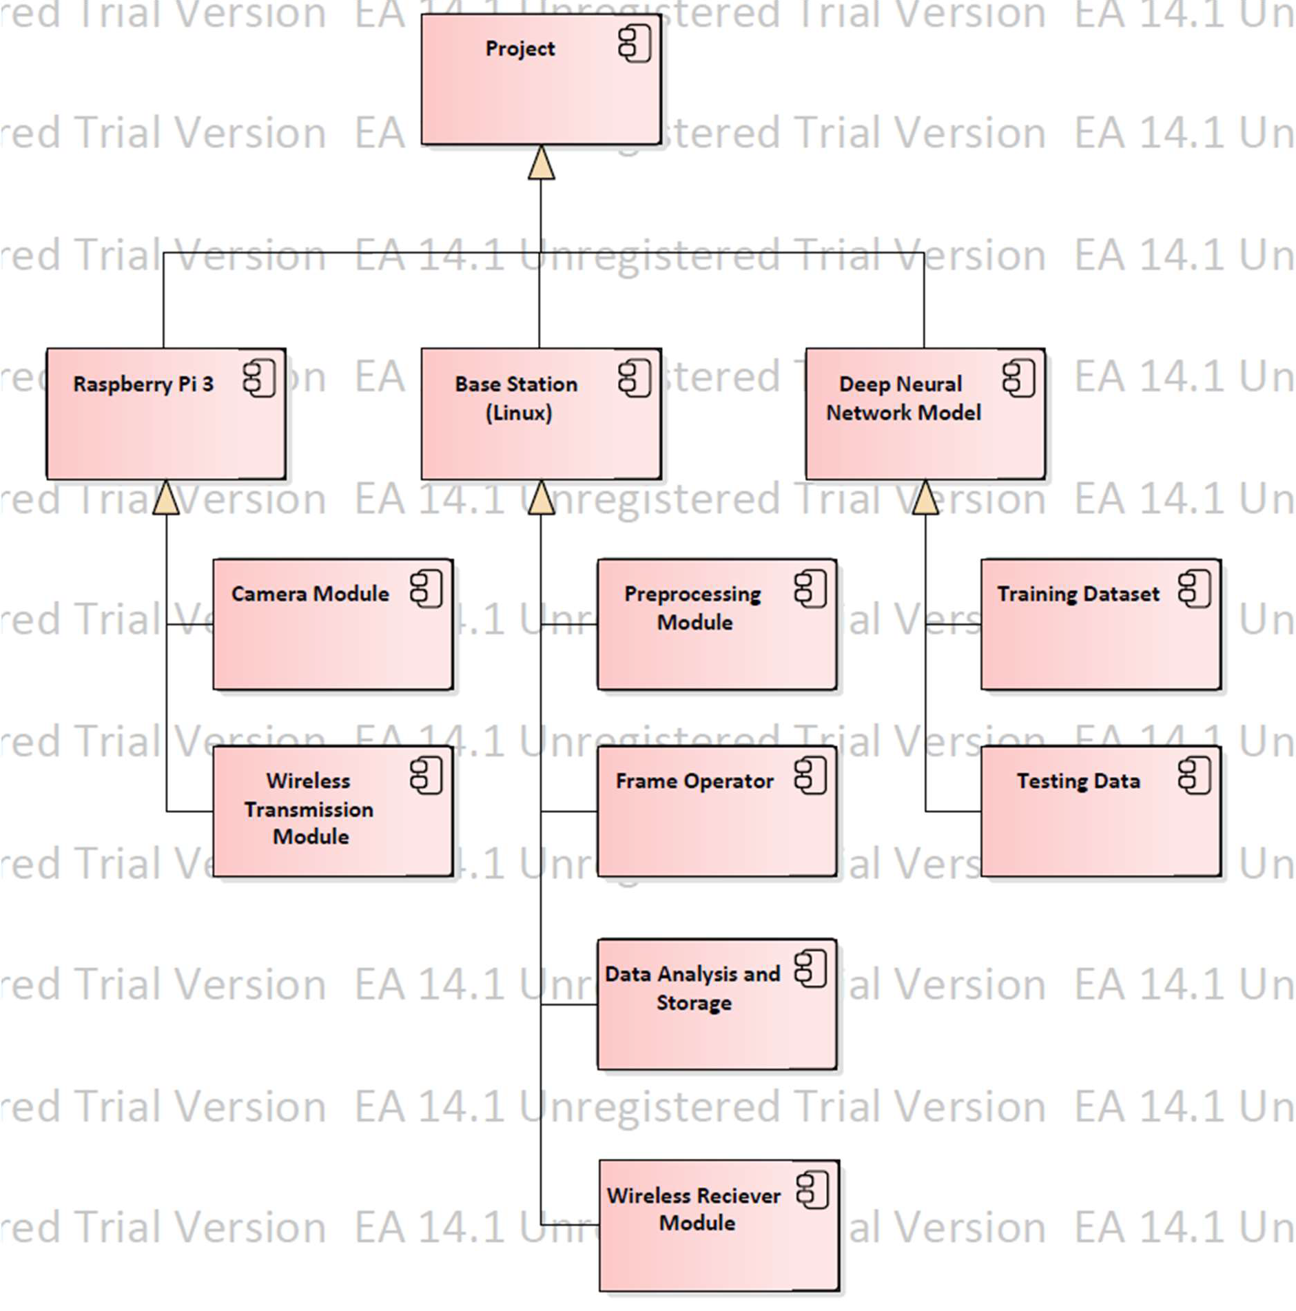

## The Raspberry PI

The Raspberry Pi is a small single-board computer model. It does not include peripherals (such as keyboards and mice) and cases.

We used the Raspberry PI 3 for this project. It is equipped with a 1.2 GHz 64-bit quad core processor with on-board Wi-Fi and Bluetooth.

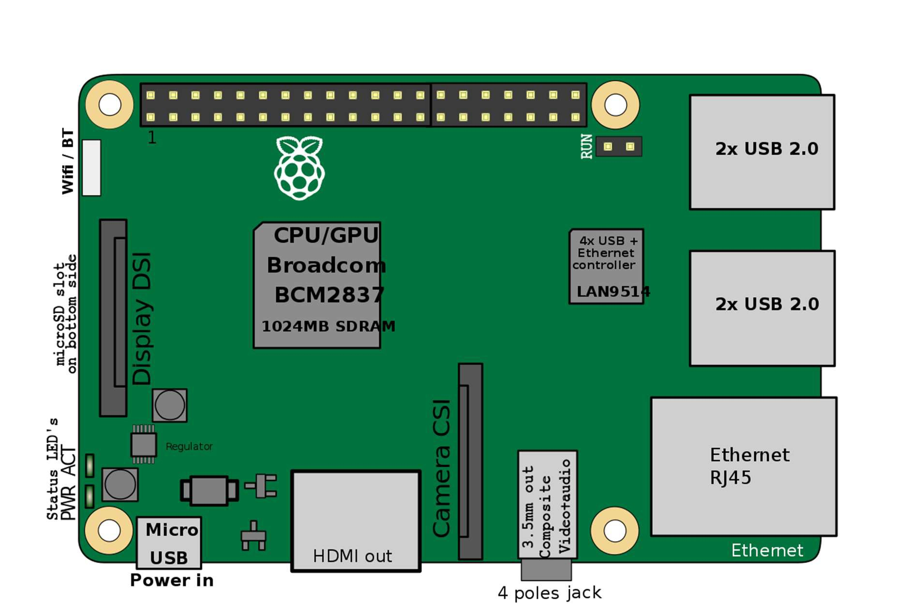

## The Base Station

The base station used for this project was an Acer Laptop. It is equipped with an Intel i5 and 8GB of RAM and had LINUX OS installed. The base station also housed a preprocessing module which would optimize gathered footage for the YOLO object detection framework. It also had a frame processor, which split the video into frames, to feed it to the YOLO object detection algorithm to process. For our data storage solution, we decided to go with Google Drive.

## Deep Neural Network

The Deep Neural network ran on the YOLO object detection framework.

YOLO (You Only Look Once), is a network for object detection. The object detection task consists in determining the location on the image where certain objects are present, as well as classifying those objects.

Previous methods for this, like R-CNN and its variations, used a pipeline to perform this task in multiple steps. This can be slow to run and also hard to optimize, because each individual component must be trained separately.

YOLO uses deep learning and convolutional neural networks (CNN) for object detection. Thus, it stands out from its “competitors” because, as the name indicates it only needs to “see” each image once. This allows YOLO to be one of the fastest detection algorithms (naturally sacrificing some accuracy). Thanks to this swiftness YOLO can detect objects in real time (up to 30 FPS).

The testing data we used were video recordings of the badminton finals of Spree 2019 taken by us personally.

# Use Cases

## Use Case Diagram

We have created the following component diagram as a part of this project:

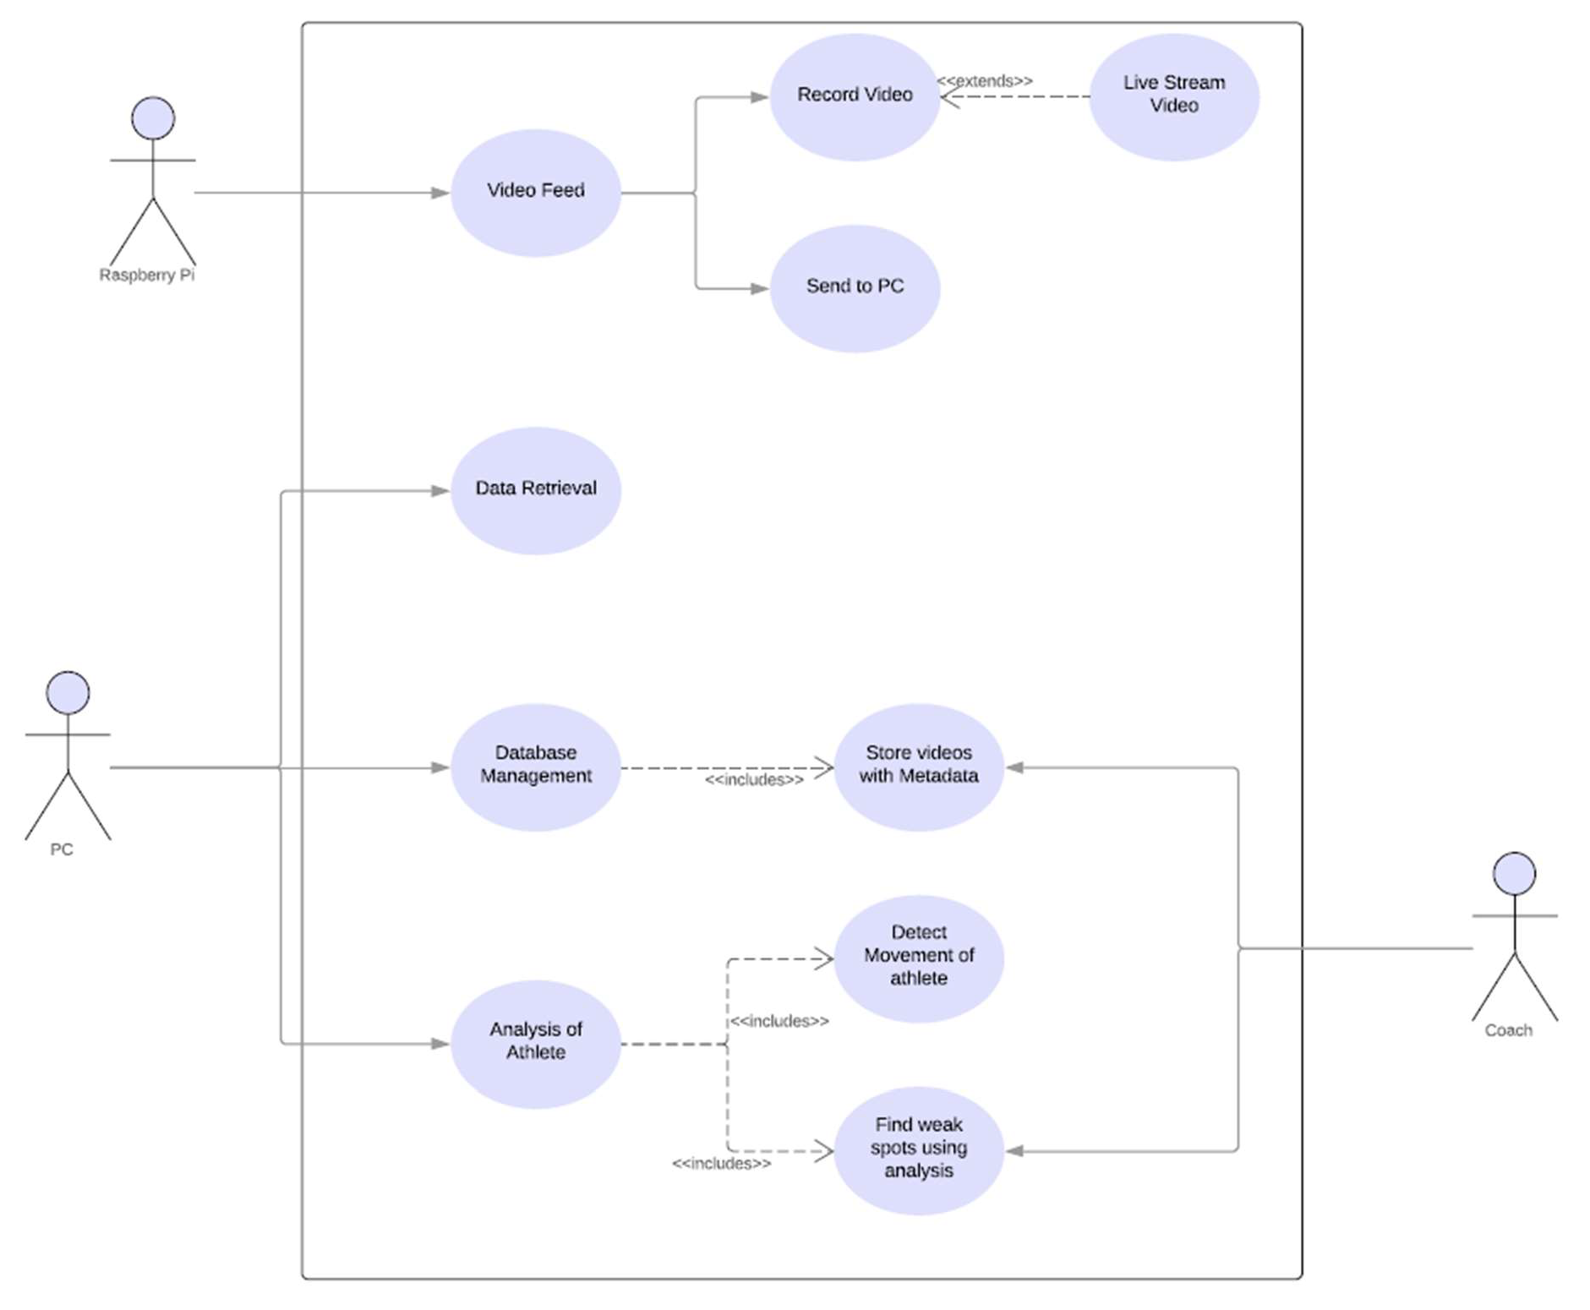

## The Actors

We have three actors as a part of our use case diagram. First is the Raspberry PI. It’s utility is to record the video footage of the athlete who we are recording and pass the recorded video feed on to the base station for further processing.

Secondly, we have the PC, which acts as the base station, and is our connection to the Google Cloud GPU which will be doing all the Neural Network Computations. It also stores a copy of the video feed sent to it from the Raspberry PI and uploads another copy of the data to Google Drive for data redundancy and safekeeping.

Lastly, we have the coach, who will be the end consumer of the information. The inferences and analysis drawn from the data by the Neural Network is to be served to him.

## Utility of the Raspberry PI

We have tuned the Raspberry PI to record at 480p and 18 FPS in the best case scenario using the Raspberry PI camera module, which was essentially a Logitech Webcam connected to it via USB.

The Raspberry PI would also transfer the video feed data it would record via wireless transmission to the base station by SCP protocol.

## Utility of Data Storage

We required a data storage solution which would be safe and extensible to store the video received from the Raspberry PI. It should also be easily accessible, preferably by multiple users, as we were a team of two working on this project. Also, the testing data gathered should be easily transferable as input to our GPU solution of choice.

Hence, we chose to use Google Drive as our Data Storage utility of choice.

Our choice boiled down to two main reasons. First reason was so as to have a backup of the footage at all times. Second reason was that Google Cloud GPU allows data to be directly fed in through data stored on Google Drive.

## Utility of Data Processing Unit

We required a Data Processing solution which had powerful enough graphics capabilities to run our computationally heavy use case. It should also have the ability to run YOLO algorithm (our object detection algorithm of choice). Efficiently.

Accessibility by multiple users would be a boon as both of us could work independently but still see the progress being made by our counterparts. One more important aspect would be its ability to read testing data and write inferences directly to and from our storage solution of choice, which was Google Drive.

Hence, we chose to use Google Cloud GPU (Colaboratory) as our Data Storage utility of choice.

# The Process

## The Swim Lane Diagram

Our swim lane diagram depicts the process flow we followed during the completion of our project. It has been attached below:

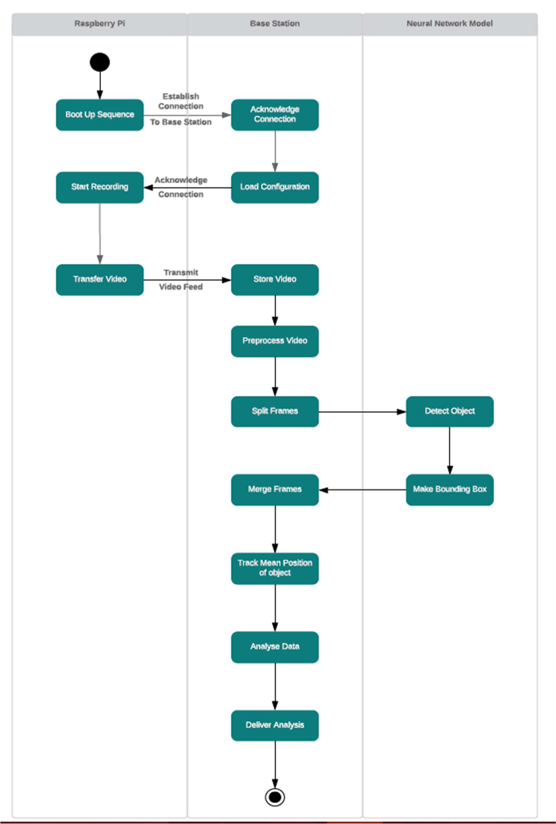

## Phase 0

This was the phase in which we got our project management tools together and set them up to be utilized. We chose Trello as our project management program of choice as we preferred the Kanban style of working.

We created three lists in Trello, To-do, Doing and Done. We then allotted work to each other based on each other’s fields of interest. This way we were able to manage the project well and complete it in time.

## Phase 1

This phase consisted of creating the boot up sequence of the Raspberry PI to finding out a way to store the recorded video into the base station. The Raspberry PI was set up with a camera module, which was essentially a Logitech Webcam attached to it via the USB port. After it was configured, we ran a basic smoke test of the functionality by recording Table Tennis matches in our hostel common rooms.

After being satisfied with the quality and frame rates the camera was giving, we proceeded to tune it a bit more and get it ready to record during Spree. We managed to record the whole Spree 2019 Badminton finals match, which was around 2 hours of collected footage and took up around 3GB of storage on our Base Station. We also uploaded all the data to Google Drive for reasons mentioned previously.

## Phase 2

This phase consisted of the Preprocessing of the video to the frame merging once the object detection was completed. As far as preprocessing goes, we cropped the video in the shape of the badminton court using Adobe Premiere Pro, in order to decrease the noise in the video and prevent any

accidental detections of people by the Object Detection Framework. The frame splitting, dbject detection, Bounding box making and frame merging was taken care of by the YOLO detection algorithm.

## Phase 3

In phase 3, we extracted the data the YOLO algorithm had created through detection of the athletes from the video data. This data was then converted into a CSV file and downloaded to the base station. At the base station, it was then cleaned and optimized to make it easier to perform analysis on.

The CSV file before cleaning looked something like this: (This is just one snippet of the whole file. The complete file had around 3400 data points.)

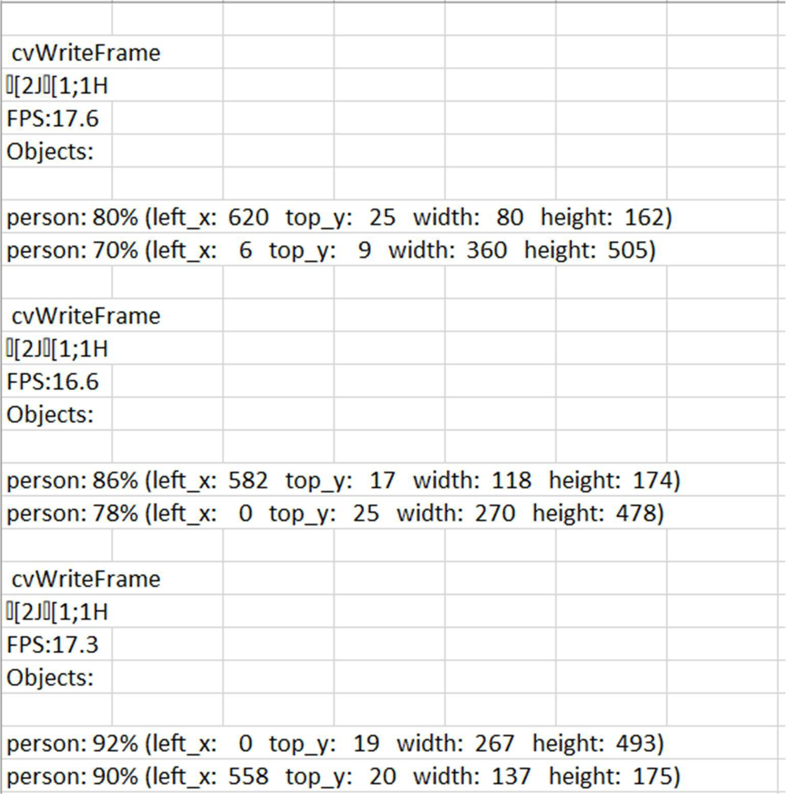

After cleaning and optimizing, it looked like this:

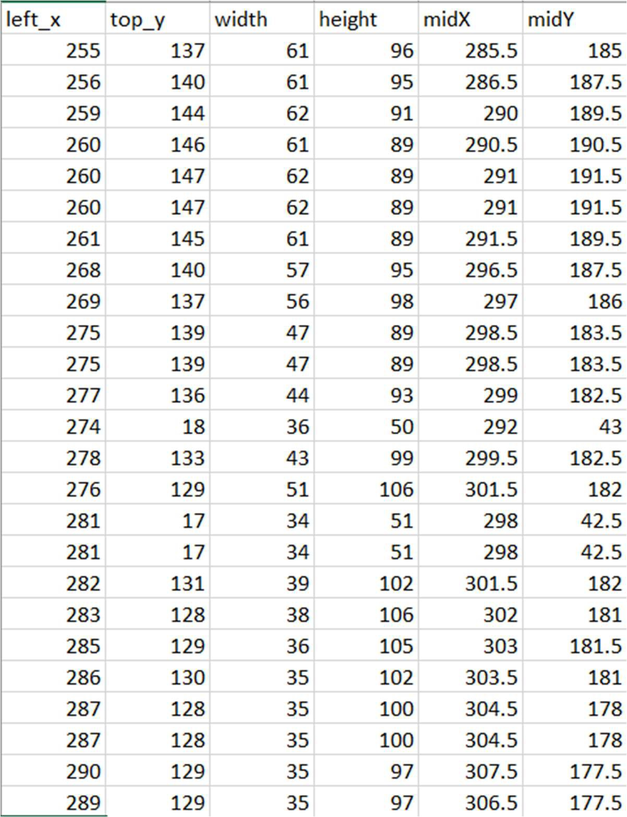

## Phase 4

In this final phase, the cleaned CSV was analyzed using MatPlotLib, and two major analysis were drawn from the data.

The first was a video which was generated from the data points, tracking the player as he moves around the court, which is completely in synchronization with the video feed of the player.

The second was a heat map of the player and his positions. This analysis is of utmost importance as it tells his positions on the field during a match, which can help us determine where the opposition player is playing the shuttle to our player the most.

# Analysis

## Player Tracking

As our first sports analysis, we were able to successfully track the player’s movement on the playing field. This has been demonstrated as a part of the video in the presentation. A screenshot of what it looks like at certain points are below:

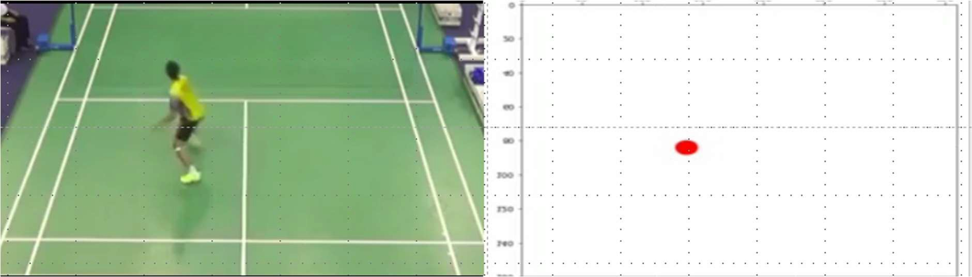

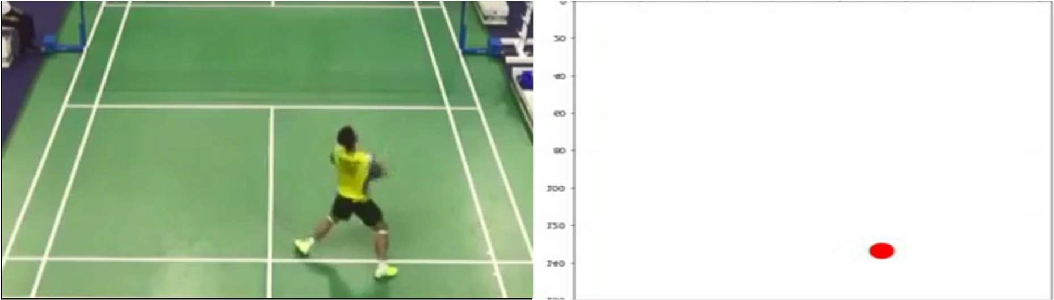

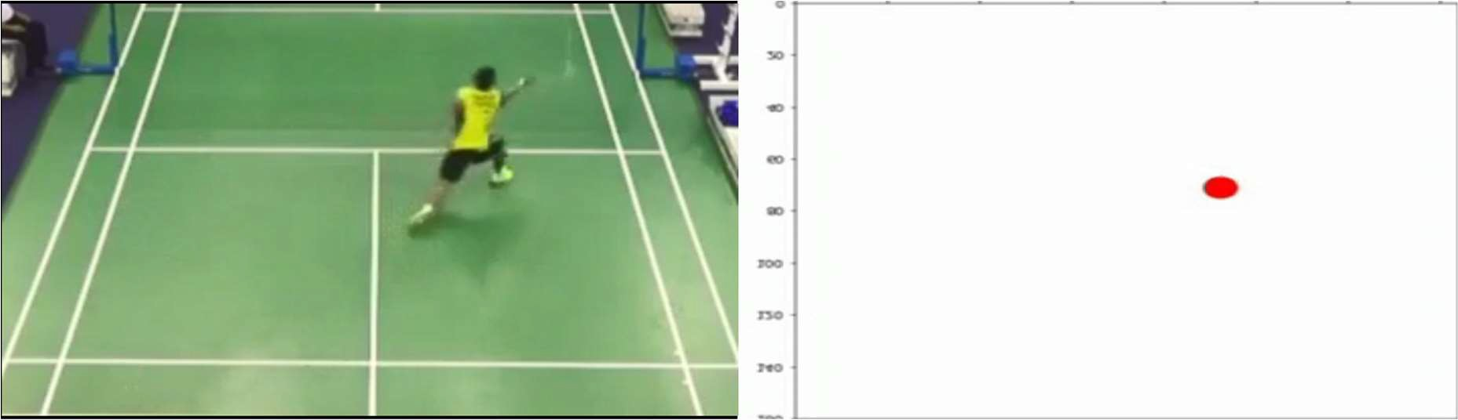

## Heat Map

The Heat Map is an essential part of sports analytics. Heat Maps in

football or any other Sport are used to identify the frequency of events spread in a given particular area.

We were able to generate a Heat Map of our athlete using the CSV file of his positions with respect to time over the field. The generated Heat Maps look like as follows:

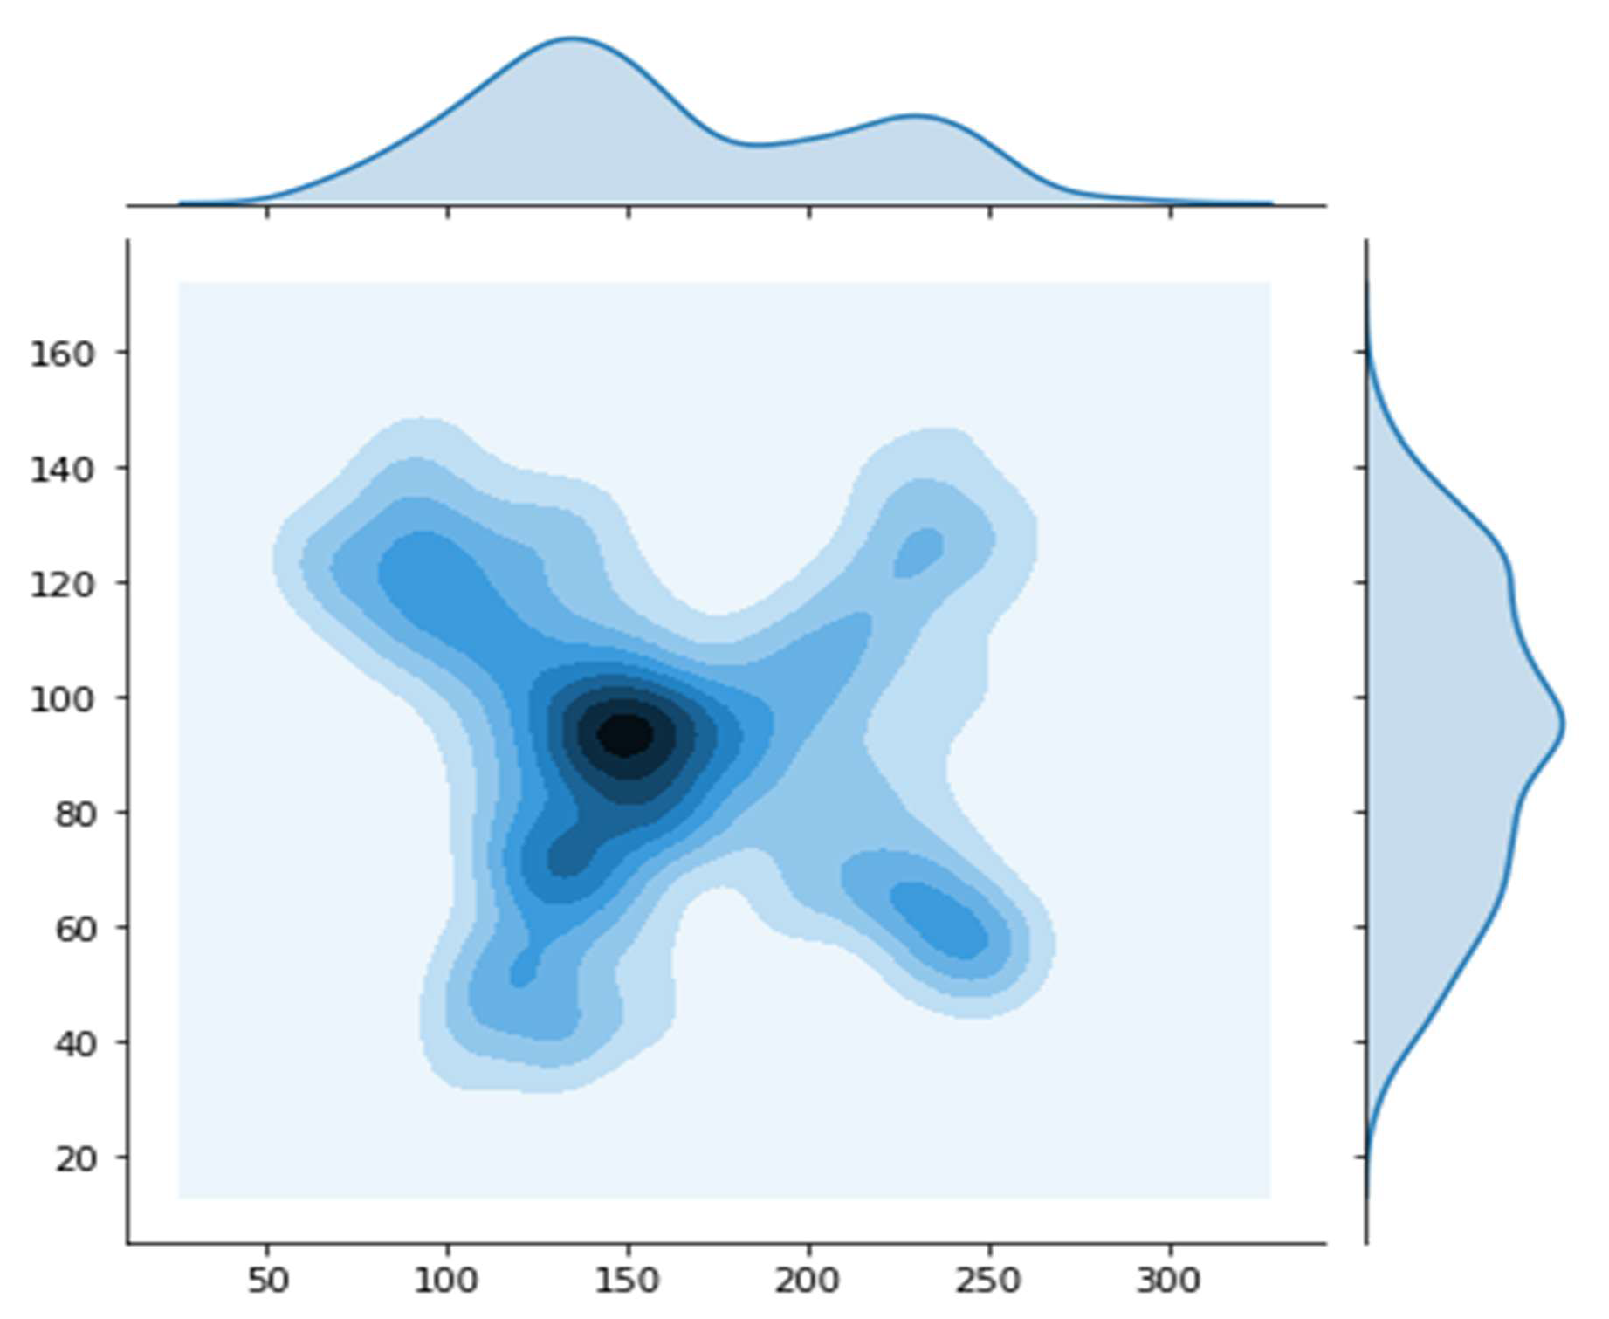

From this, we can draw inferences like:

* Our player is in the left center of the court for the most amount of time.
* The opponent is giving our player the most shots in the left front and back right the most times. So we can train our athlete to play these shots more effectively to beat the opposition.

# Conclusion

There is no denying to the fact that analytics have transformed many businesses across the globe. And now it has marked its presence in the space of sports.

Communicating data efficiently is what sports analytics all comes down to. Without people to analyze and interpret these numbers, they have no meaning to other professionals in the industry. Thanks to numerous practical applications both on and off the field, sports analytics is becoming increasingly essential to virtually every aspect of player, team and organization management.

Sports analytics are crucial to many teams by helping them become their best through interpretation and analysis of statistics gained in practices and games. With time both sports and technology evolve, and with that, the role of analytics in sports will continue to become vital. The more competitive sports become the more teams and sports organization will look out for analytics to better their game.